Disclaimer:
The Conservation and Survey Division (CSD) strives to ensure the accuracy of data provided via the Nebraska GeoView website and related services within the limits of practicality and the widely recognized limitation of large legacy datasets. The data displayed herein are provided by third parties and, as such, CSD cannot guarantee the accuracy of such data. This data is for informational purposes only. Any conclusions drawn or interpretations of any data accessed through this site are the sole responsibility of the user. Neither CSD nor the University of Nebraska is liable or responsible for any errors, omissions or damages resulting from interpretation of the data. The foregoing warning is exclusive and in lieu of all other warranties of merchantability, fitness for a particular purpose, and/or any other type whether express or implied. In no event shall CSD, the University of Nebraska, or any other data providers become liable to users of this data, or any other party, for any loss or direct, indirect, special, incidental or consequential damages, including, but not limited to, time, money, or goodwill, arising from the use or modification of the data. For questions, contact Jesse Korus at 402-472-7561 or jkorus3@unl.edu.

How to use GIS web services:

1. Open ArcGIS Pro
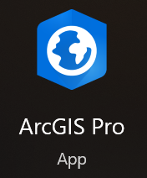
2. Insert New Local Scene
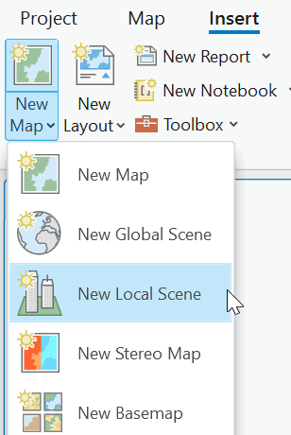
3. Add data -> Add data from path
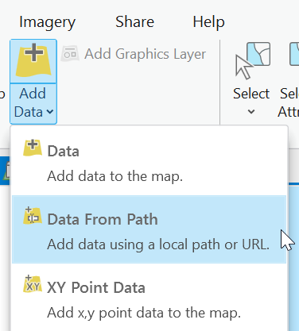
4. Copy URL from list below and paste into path
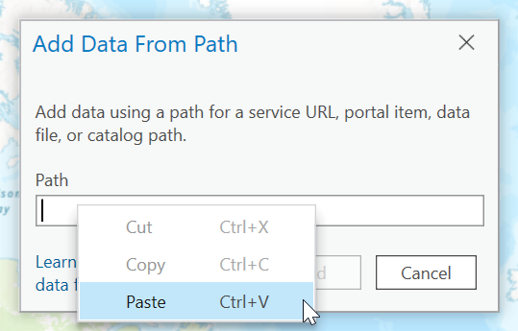

ArcGIS Web Services for AEM resistivity models
Natural Resources District (NRD) | Survey year & system | ArcGIS Web Service URL
Lewis and Clark NRD | 2016 SkyTEM 304M | https://csdgis.unl.edu/csdgis/rest/services/Hosted/KORUSDATA2_LCNRD_2016_SkyTEM304M_29lyrSCI/SceneServer
 | 2018 SkyTEM 304M | https://csdgis.unl.edu/csdgis/rest/services/Hosted/KORUSDATA2_LCNRD_2018_SkyTEM304M_39lyrSCI/SceneServer
 | 2018 SkyTEM 312 | https://csdgis.unl.edu/csdgis/rest/services/Hosted/KORUSDATA2_LCNRD_2018_SkyTEM312_39lyrSCI/SceneServer
Middle Republican NRD | 2020 SkyTEM 304M | https://csdgis.unl.edu/csdgis/rest/services/Hosted/KORUSDATA2_MRNRD_2020_SkyTEM304M_39lyrSCI/SceneServer
 | 2022 SkyTEM 304M | https://csdgis.unl.edu/csdgis/rest/services/Hosted/KORUSDATA2_MRNRD_2022_SkyTEM304M_39lyrSCI/SceneServer
 | 2023 SkyTEM 304M | https://csdgis.unl.edu/csdgis/rest/services/Hosted/KORUSDATA2_MRNRD_2023_SkyTEM304M_39lyrSCI/SceneServer

